Step 1: Open MongoDB Atlas
- Open MongoDB Atlas.
- Log in.
- Open your Project.
- Go to Database.
- Click Browse Collections.

PART A — Create Database and Collection

Step 2: Create the database
If bookflow does not already exist:
- Click Create Database.
- Enter:
Database Name
bookflow
Collection Name
book_metadata
- Click Create.
If bookflow already exists, just create the collection:
book_metadata
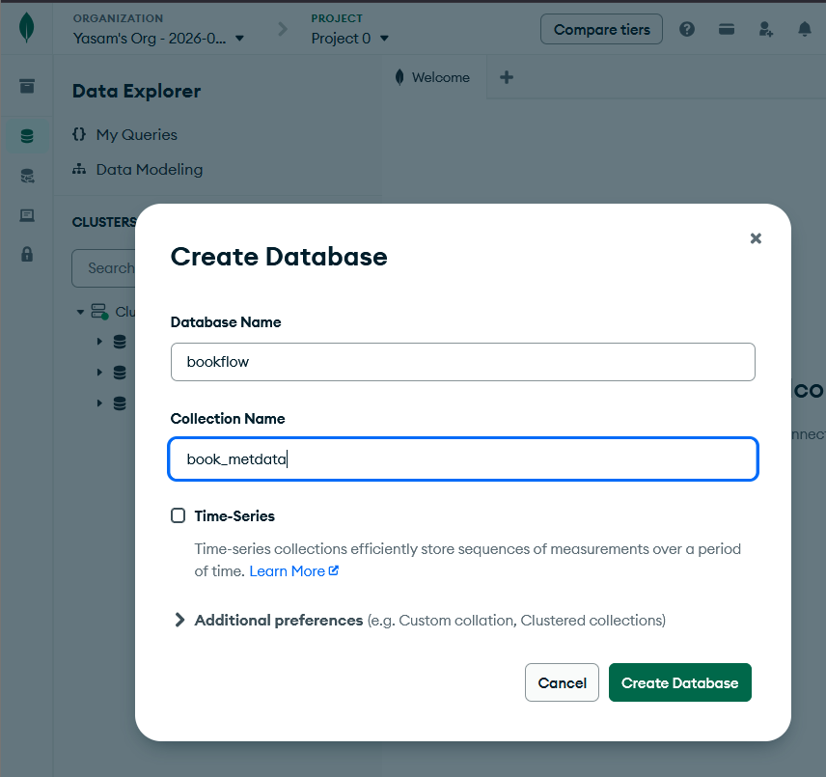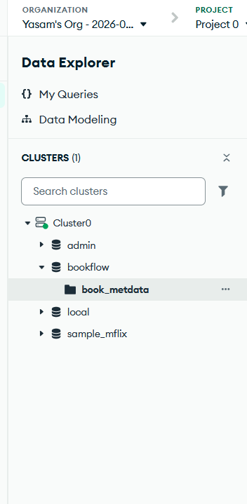

PART B — Insert the 5 Documents
Step 3: Open the collection
Go to: Bookflow -> book_metadata -> Documents
Click: Add Data → Insert Document
Paste each document one by one.
Document 1
{
"book_id": 101,
"title": "The Martian",
"author": "Andy Weir",
"published_year": 2021,
"category": "Science Fiction",
"format": "Digital PDF",
"file_size": "2.5 MB",
"member_id": 101,
"reviews": [
{
"member_id": 101,
"rating": 5,
"comments": "Excellent science fiction story"
},
{
"member_id": 102,
"rating": 4,
"comments": "Very interesting and informative"
},
{
"member_id": 103,
"rating": 5,
"comments": "Excellent space adventure"
}
]
}
Click Insert.

Document 2
Again:
Add Data → Insert Document
{
"book_id": 102,
"title": "Dune",
"author": "Frank Herbert",
"published_year": 2022,
"category": "Science Fiction",
"format": "Digital EPUB",
"file_size": "3.1 MB",
"member_id": 102,
"reviews": [
{
"member_id": 101,
"rating": 5,
"comments": "Amazing world building"
},
{
"member_id": 104,
"rating": 4,
"comments": "Classic science fiction novel"
},
{
"member_id": 105,
"rating": 5,
"comments": "Excellent characters and story"
}
]
}
Click Insert.

Document 3
{
"book_id": 103,
"title": "Clean Code",
"author": "Robert C. Martin",
"published_year": 2019,
"category": "Programming",
"format": "Physical",
"dimensions": {
"height": "23 cm",
"width": "18 cm",
"weight": "700 g"
},
"member_id": 103,
"reviews": [
{
"member_id": 101,
"rating": 5,
"comments": "Excellent programming reference"
},
{
"member_id": 106,
"rating": 4,
"comments": "Very useful coding practices"
}
]
}

Document 4
{
"book_id": 104,
"title": "Artificial Intelligence Basics",
"author": "John Smith",
"published_year": 2023,
"category": "Artificial Intelligence",
"format": "Digital PDF",
"file_size": "4.2 MB",
"member_id": 104,
"reviews": [
{
"member_id": 102,
"rating": 4,
"comments": "Good introduction to artificial intelligence"
},
{
"member_id": 105,
"rating": 5,
"comments": "Excellent machine learning explanation"
},
{
"member_id": 106,
"rating": 4,
"comments": "Useful for beginners"
}
]
}

Document 5
{
"book_id": 105,
"title": "Data Structures",
"author": "Mark Allen",
"published_year": 2024,
"category": "Computer Science",
"format": "Digital PDF",
"file_size": "5.0 MB",
"member_id": 105,
"reviews": [
{
"member_id": 101,
"rating": 5,
"comments": "Excellent data structures book"
},
{
"member_id": 107,
"rating": 3,
"comments": "Good but needs more examples"
}
]
}
After inserting, you should have 5 documents. 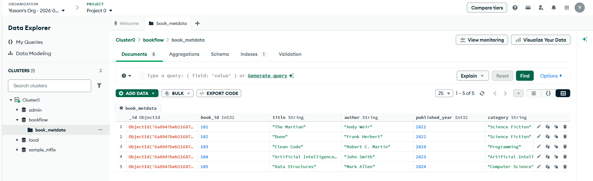

PART C — Run Normal Queries
For these queries:
- Open book_metadata.
- Go to Documents.
- Find the Filter box.
- Paste the query.
- Click Find.
Query 1: Rating greater than 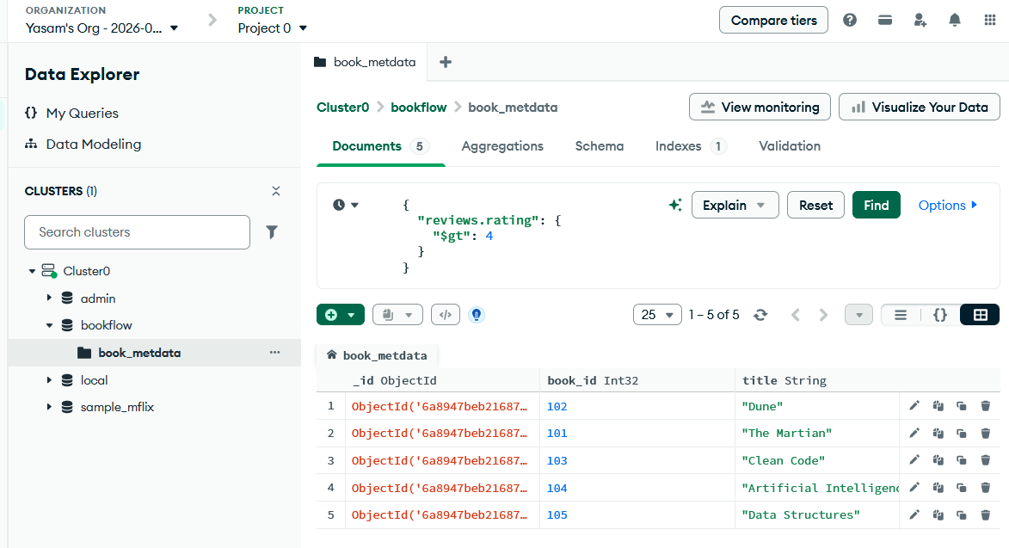

Query 2: Rating is 4 or 5
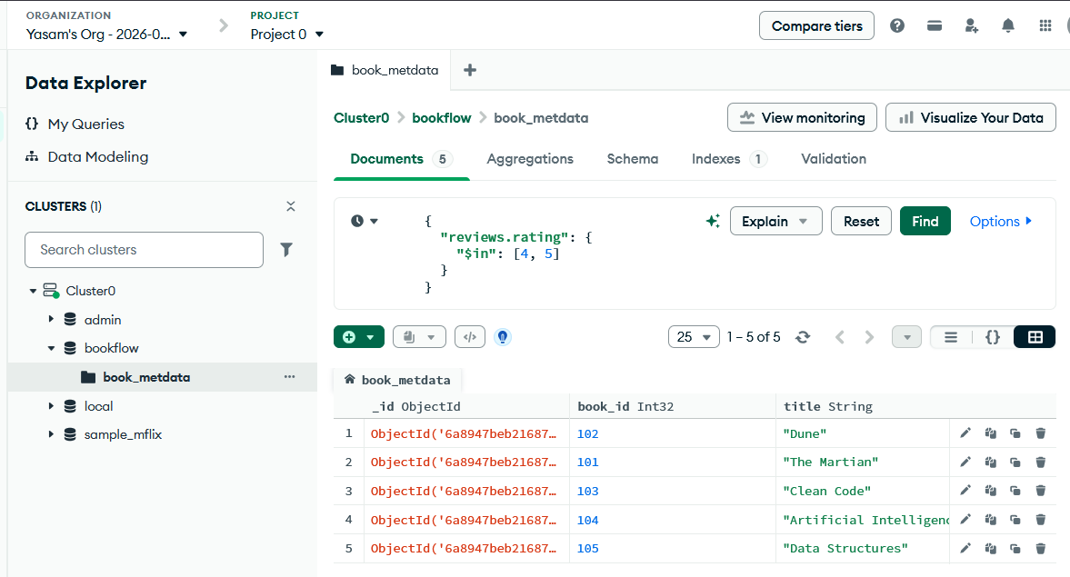

Query 3: Find Digital books
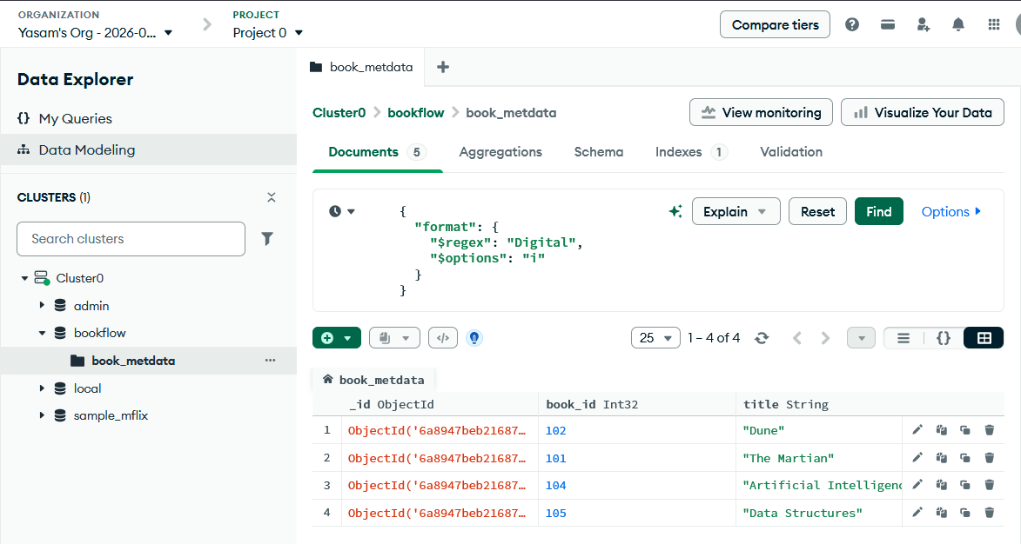

PART D — Aggregation Pipeline
Stage 1: $match
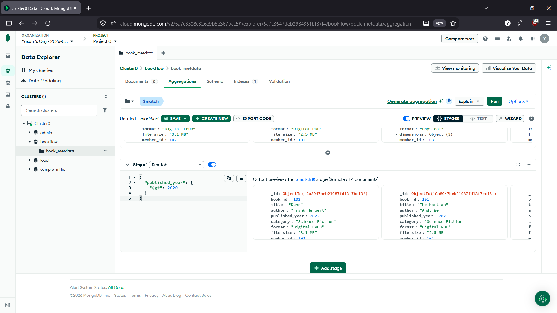

Stage 2: $unwind
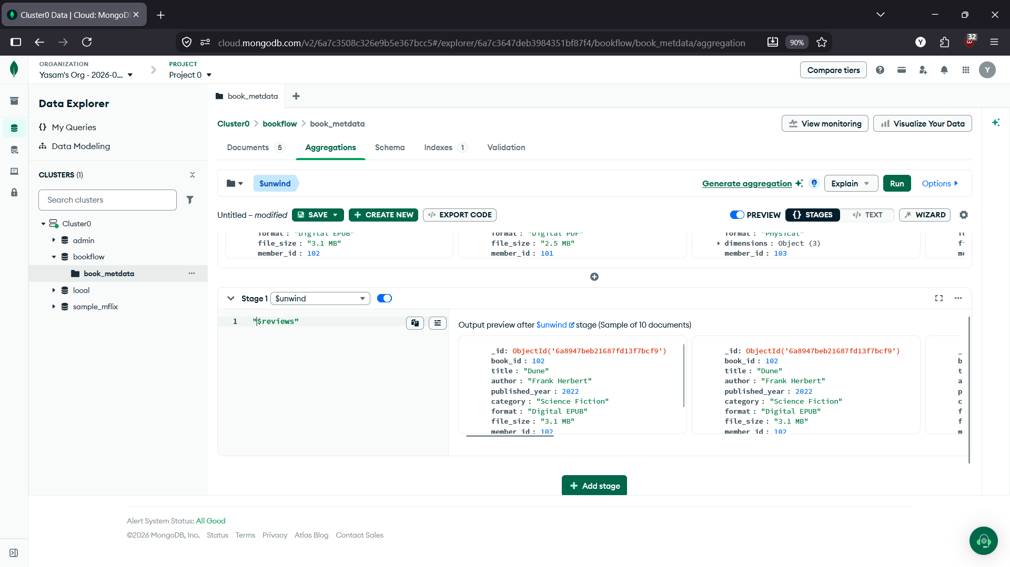

Stage 3: $group
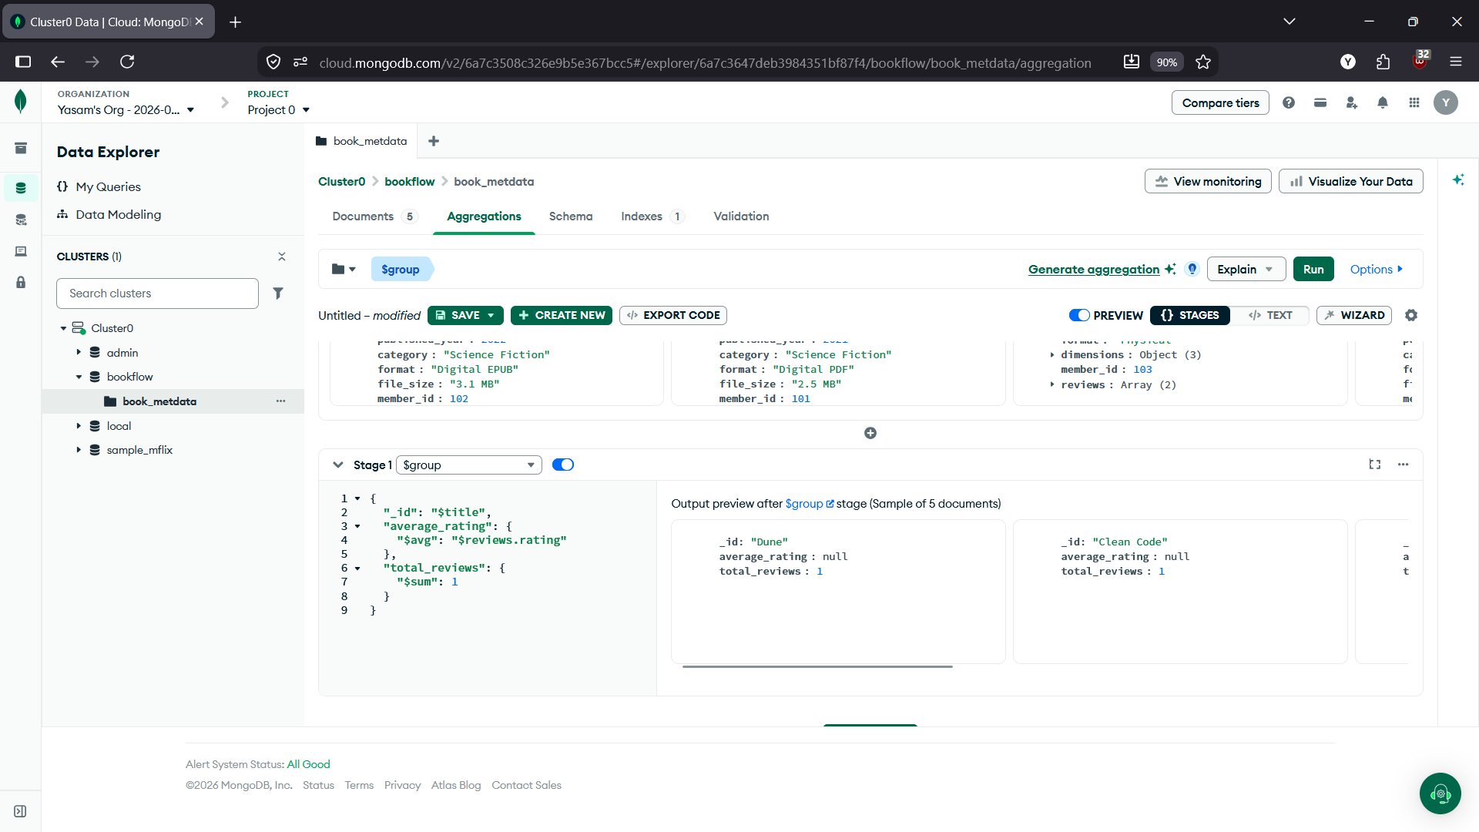

Stage 4: $sort
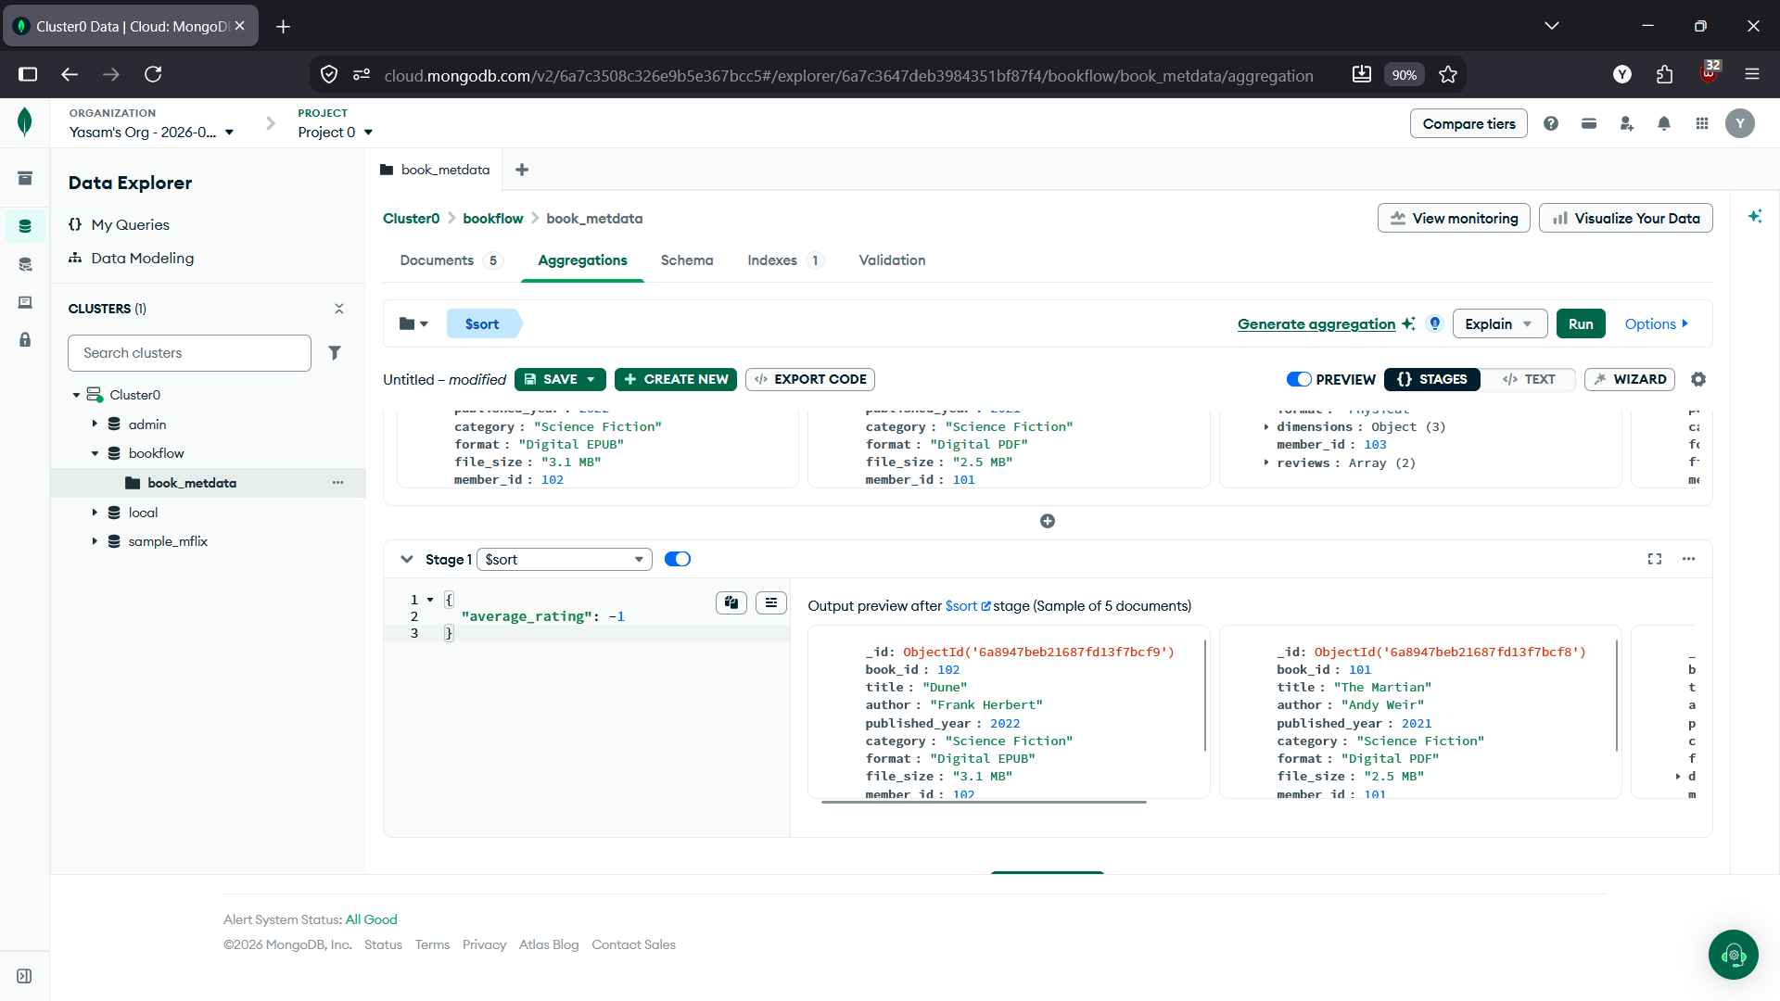

COMPLETE AGGREGATION PIPELINE
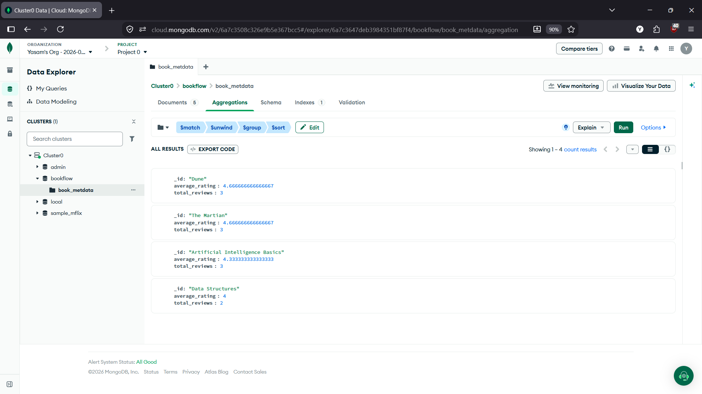

PART E — Create Text Index
Go back to:
book_metadata → Search Indexes
If your Atlas interface shows Indexes under the collection, open Indexes.
Create an index on:
reviews.comments
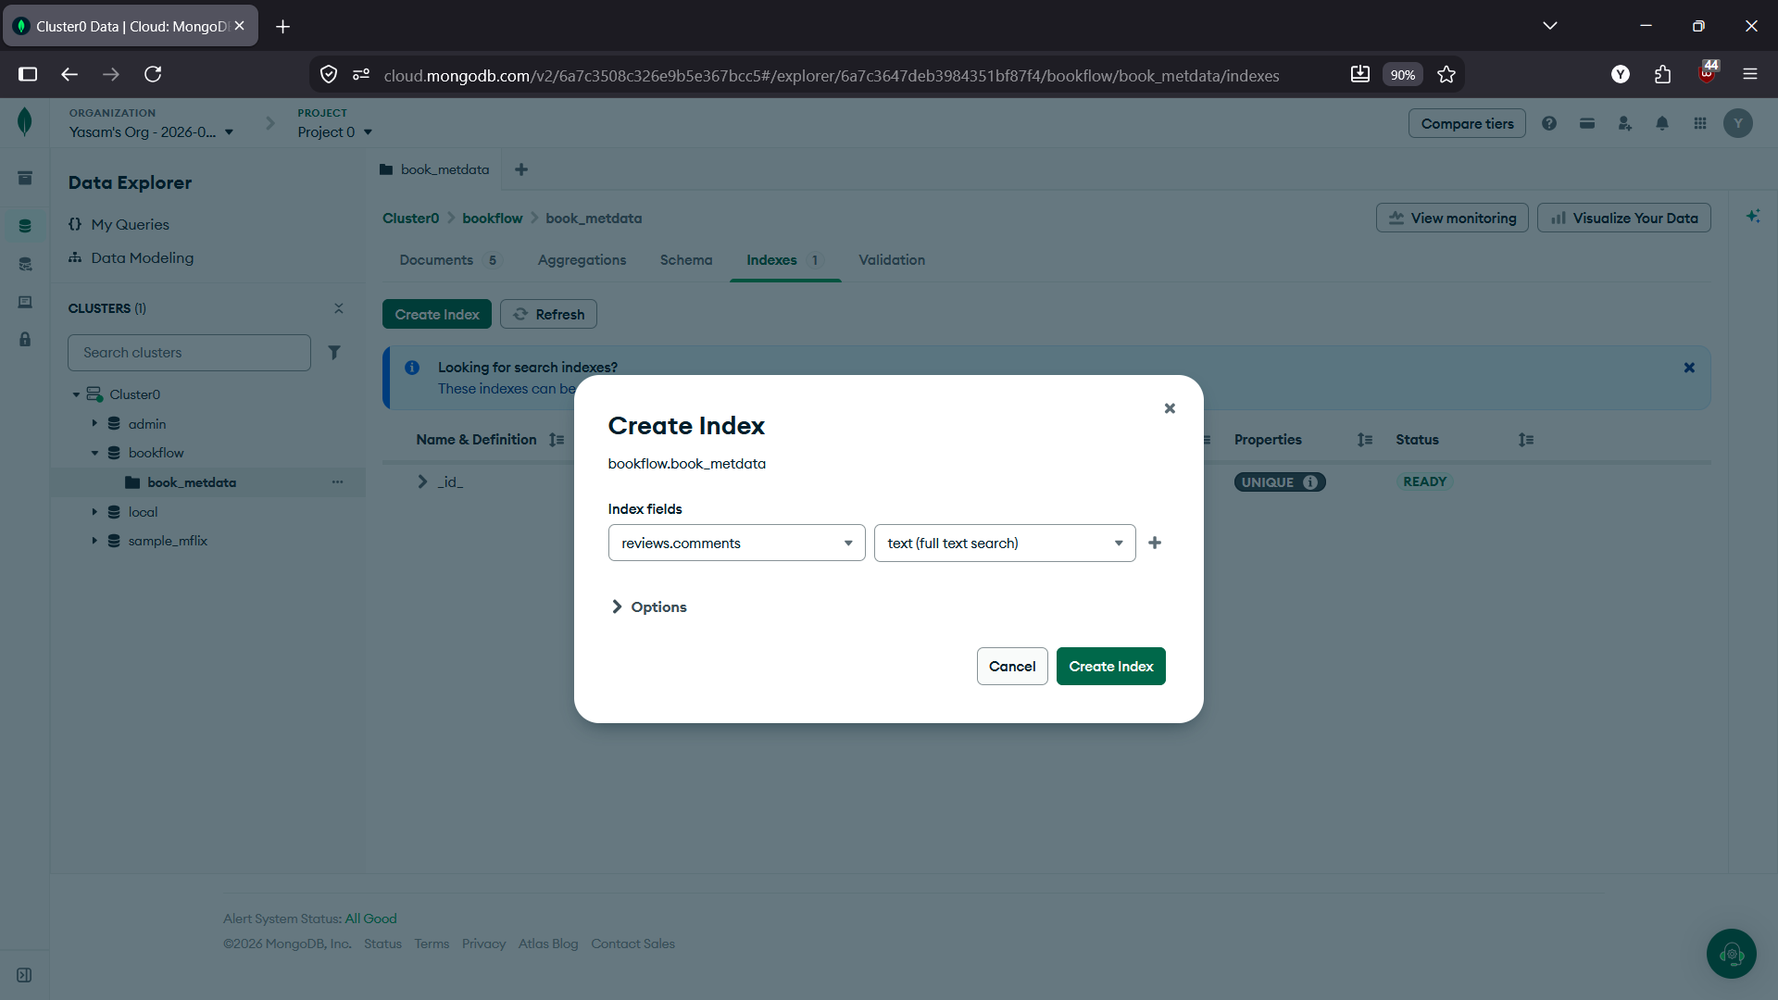
PART F — Text Search
Search for the keyword: excellent and science fiction